Software Engineering 2017

# Group ID: B04

## *Traffic Challan Management*

|  |
| --- |
| 20171005_230039.jpg |

|  |  |  |
| --- | --- | --- |
| Roll Number | Name | Role (PO+DEV/SM+DEV/DEV) |
| 15ucs121 | Satyam Kumar | DEV |
| 15ucs138 | Shubham Mangal | SM + DEV |
| 15ucs154 | Utsav Singh | PO + DEV |
| 15ucs122 | Satyam Shubham | DEV |
| 15ucs108 | Rishabh Tiwari | DEV |

*+ order the names as per the order in the team selfie (left to right)*

## Section 1

|  |
| --- |
| **Project overview**  Traffic Challan Management system provides the following functionality:   1. Offers the data about commuters using their vehicle’s license number, 2. Penalize the road rules offenders by issuing the challan against the vehicle’s license number, 3. Helps the traffic officer to manage and regulate the challan generation automatically and hassle free, 4. Provide platform to pay the challan fine amount online |

|  |
| --- |
| **System purpose**  To reduce difficult paperwork of challan generation by traffic officer, to efficiently generate challan and reduce the time consumed in manual work, to provide better traffic regulations, and to provide online platform for offenders to pay fine. |

## Section 2

**URI for System Demo**

[**Demo Link**](https://t-challan.firebaseapp.com/)

**URI for UI/UX wireframes (shared Lucidchart document folder)**

[**Lucid Folder Link**](https://www.lucidchart.com/invitations/accept/b21cf4ca-f300-4ebf-be6b-9441bb8b975f)

**URI for Scrum project management report (shared Google Drive folder)**

[**Scrum Burndown Chart**](https://docs.google.com/a/lnmiit.ac.in/spreadsheets/d/19CKbj7voB_XqLPR1imq7zm9rq9j1quwTVfvpu1Lnj0c/edit?usp=sharing)

## Section 3

**Work System Snapshot**

|  |  |  |  |
| --- | --- | --- | --- |
| Customers | | Product/Services | |
| * Traffic Police Authority | | * Challan Generation * Offender Information * Challan Payment * Challan Insights * Traffic Offences Details * Officer Details | |
| Major Activities and Processes | | | |
| * Admin adds details about commuters against their license number * Admin create officers account with appropriate access rights * Traffic officer upload the image of offenders vehicle containing license number * System generate challan from the processed image * System informs the offender about the challan and payment due date * Offender visits the portal and pay the fine for challan * Wireless Control Officer checks status of payment and reminds the offender about the payment due date in case of no payment. * System update the status of due challan to “waiting court order” * Wireless Control Officer Update the status of due challan to “warrant issued” in case of no response from offender * Wireless Control Officer assign a Police Officer to the Challan * Police Officer checks if any offender’s warrant is issued * Police Officer update the status of offender’s arrest * Wireless Control Officer closes the challan after all processing * Commuters can view for any previous challan issued for their vehicle | | | |
| Participants | Information | | Technologies |
| * Offenders * Commuters * Traffic Officer * Police Officer * Wireless Control Officer * Administrator | * License Number * Offender * Challan * Traffic Offences * Payment * Assigned Officer * Warrant | | * Image Processing System * Database System * Payment Providers * Management System |

## Section 4

**Use case diagram with nested boundary**[**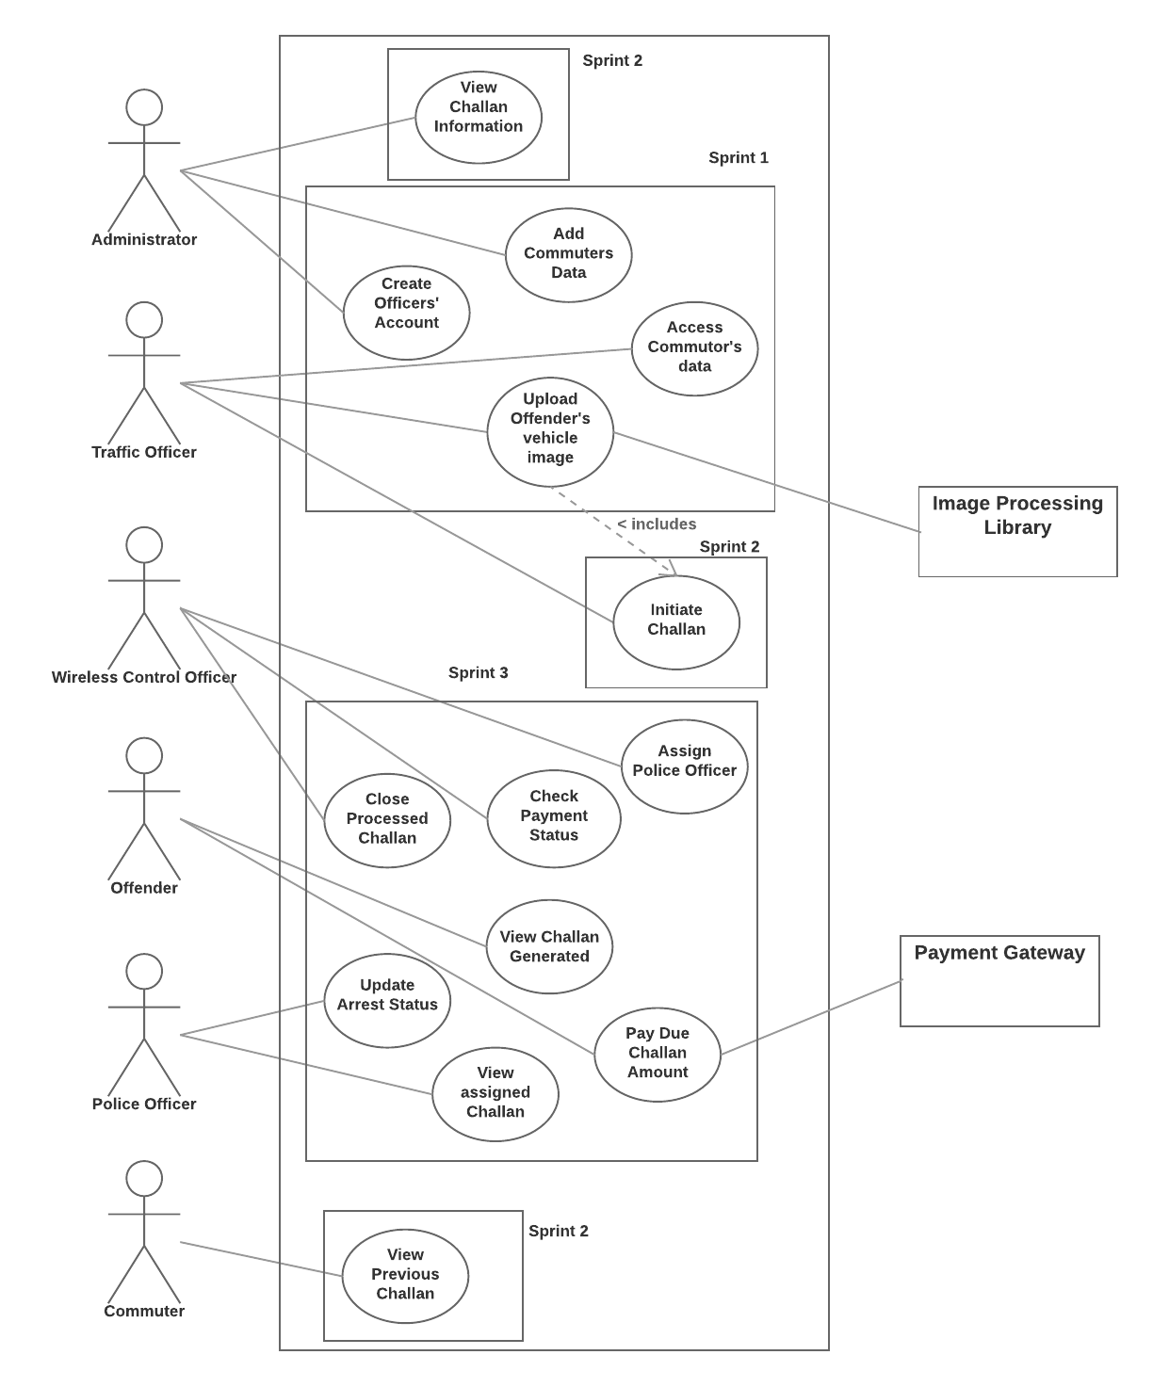**](https://www.lucidchart.com/documents/edit/59287be1-79a7-48e9-a94a-4b51be7a2571/0?callback=close&name=docs&callback_type=back&v=2415&s=612)

## Section 5

**Product Backlog (format sprint 3 rows in bold)**

|  |  |  |  |  |
| --- | --- | --- | --- | --- |
| Story ID | As a/an | I want to … | so that … | Priority (H/M/L) |
| 1 | Administrator | View road offences | Road code of conduct can be ensured | L |
| 2 | Traffic Officer | Upload vehicle image and initiate challan generation | Time consumed in paperwork can be reduced | H |
| 3 | Traffic Officer | View offenders  information | Offender can be informed about challan | M |

|  |  |  |  |  |
| --- | --- | --- | --- | --- |
| Story ID | As a/an | I want to … | so that … | Priority (H/M/L) |
| 4 | Commuter | View challan history | I can see if I have violated any road code. | L |
| **5** | **Offender** | **Access challan** | **I can pay the challan amount.** | **H** |
| 6 | Wireless Control  Officer | View challans’ details | I can check if challan has been paid or not. | H |

|  |  |  |  |  |
| --- | --- | --- | --- | --- |
| Story ID | As a/an | I want to … | so that … | Priority (H/M/L) |
| **7** | **Wireless Control**  **Officer** | **Inform Court about the**  **unpaid challan** | **Appropriate actions can be**  **taken against offender by**  **Court.** | **M** |
| **8** | **Wireless Control**  **Officer** | **View the warrant**  **information issued by**  **court** | **I can assign the police officer**  **to the warrant.** | **M** |

|  |  |  |  |  |
| --- | --- | --- | --- | --- |
| Story ID | As a/an | I want to … | so that … | Priority (H/M/L) |
| **9** | **Police Officer** | **View assigned**  **warrants** | **I can take appropriate actions**  **accordingly.** | **M** |
| 10 | Administrator | Create and assign  officers’ accounts | They can upload and manage  challan. | H |

**Sprint 3 Plan (Backlog)**

|  |  |  |  |  |  |
| --- | --- | --- | --- | --- | --- |
| Story ID | As a/an | I want to … | so that … | estimate | actual |
| **5** | **Offender** | **Access challan** | **I can pay the challan amount.** | **3 days** | 4 days |
| **7** | **Wireless Control**  **Officer** | **Inform Court about the**  **unpaid challan** | **Appropriate actions can be**  **taken against offender by**  **Court.** | **2 days** | 2 days |
| **8** | **Wireless Control**  **Officer** | **View the warrant**  **information issued by**  **court** | **I can assign the police officer**  **to the warrant.** | **3 days** | 4 days |
| **9** | **Police Officer** | **View assigned**  **warrants** | **I can take appropriate actions**  **accordingly.** | **2 days** | 3 days |

## Section 6

**Acceptance criteria and test result**

(note: a story ID may have multiple rows; one for each acceptance criteria to be tested)

|  |  |  |
| --- | --- | --- |
| Story ID | Acceptance criteria | Test Result |
| 5 | Offender is able to access the challan | Accepted |
| 7 | Wireless Officer can view challan details and court details | Accepted |
| 8 | Wireless Officer can change status of challan | Accepted |
| 5 | Offender is able to pay the challan | Accepted |
| 9 | Police Officer is able to view assigned challan | Accepted |
| 9 | Police Officer can change status | Accepted |

## Section 7

**Personas**

**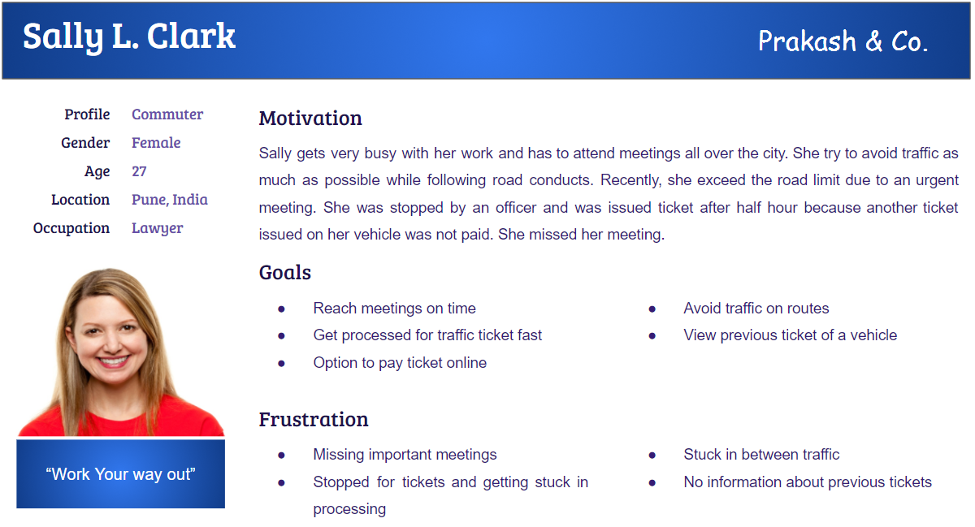**

**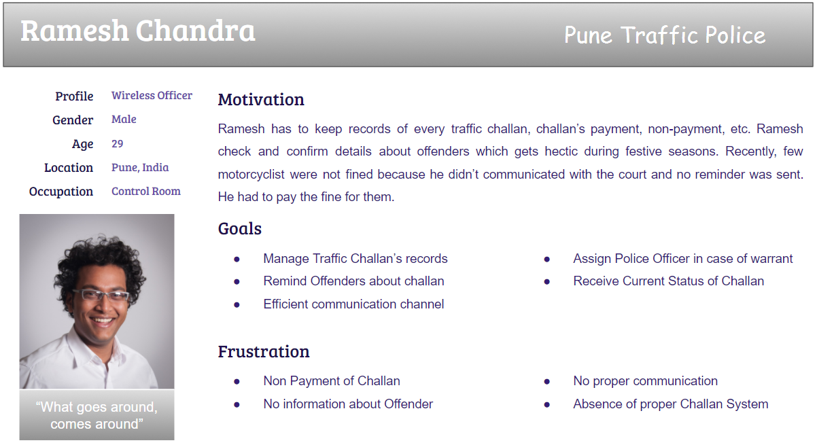**

**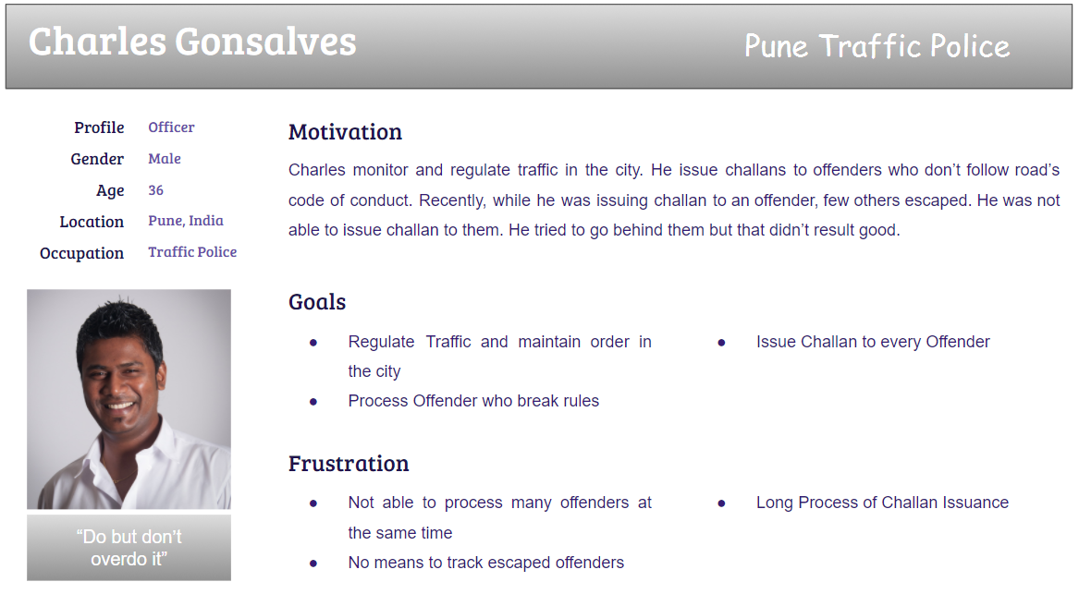**

**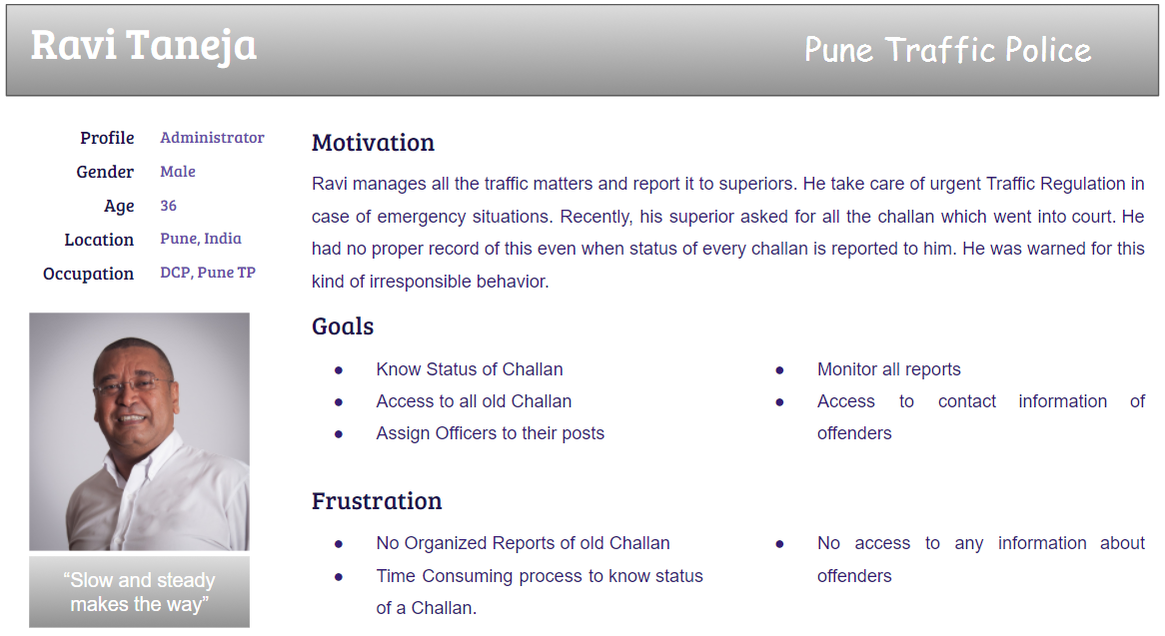**

## Section 8

**Activity diagram – Top level**

<*linking all the use cases in the use case diagram*>

[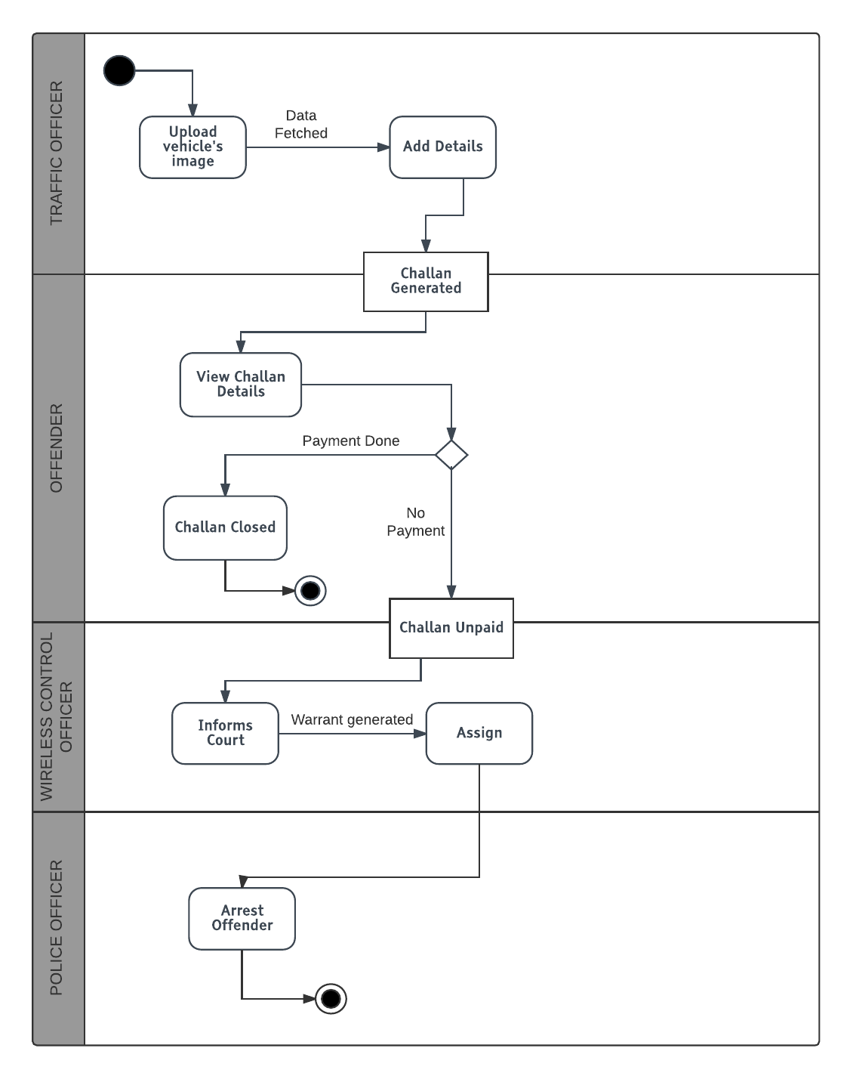](https://www.lucidchart.com/documents/edit/13f750a7-2ebb-43e8-b5f4-b136463ea6e9/0?callback=close&name=docs&callback_type=back&v=829&s=565)

**Activity diagrams**

<*Approximately one for each team member with correct notation; diagrams should include business activities/operations – not UI navigation and concepts*>

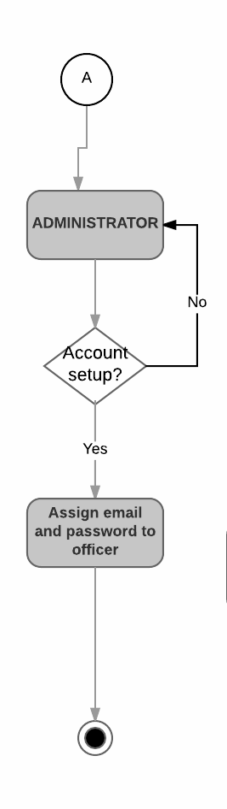

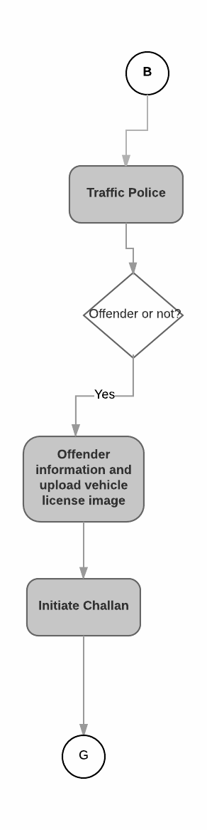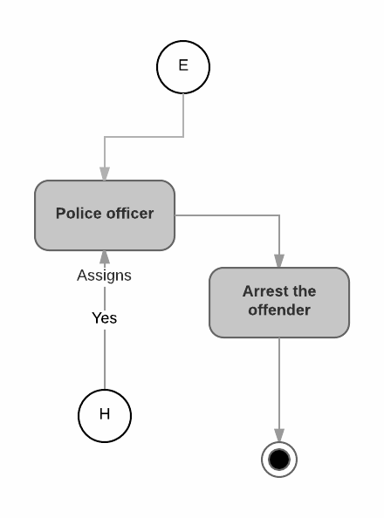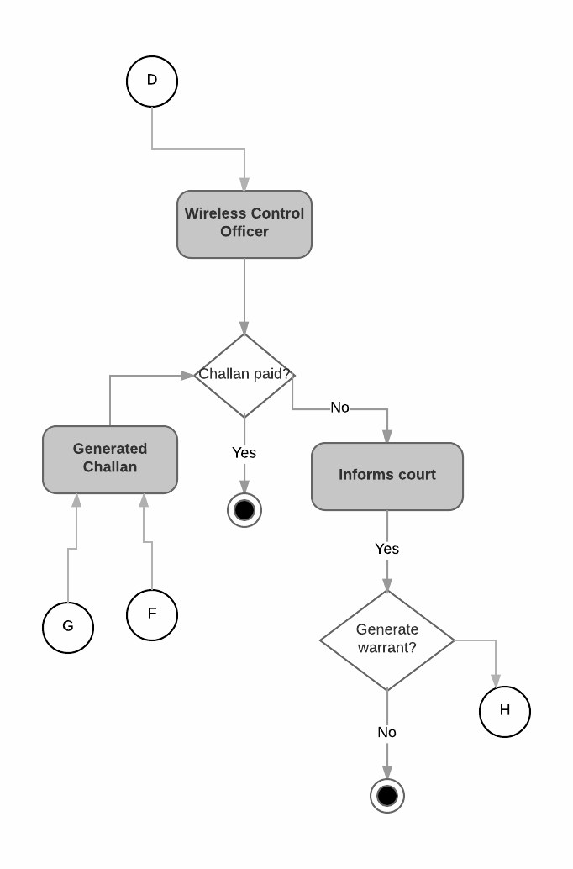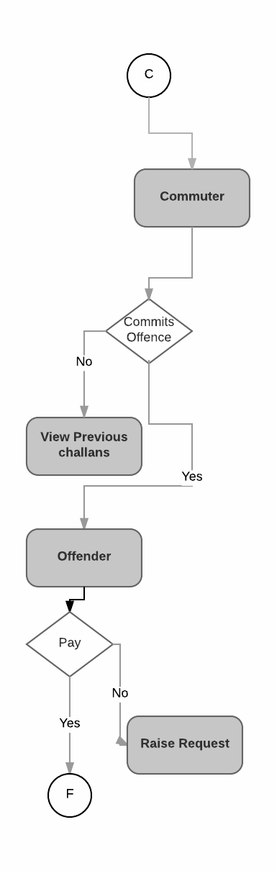

## Section 9

**Mindmaps for UX/UI for Persona Groups**

**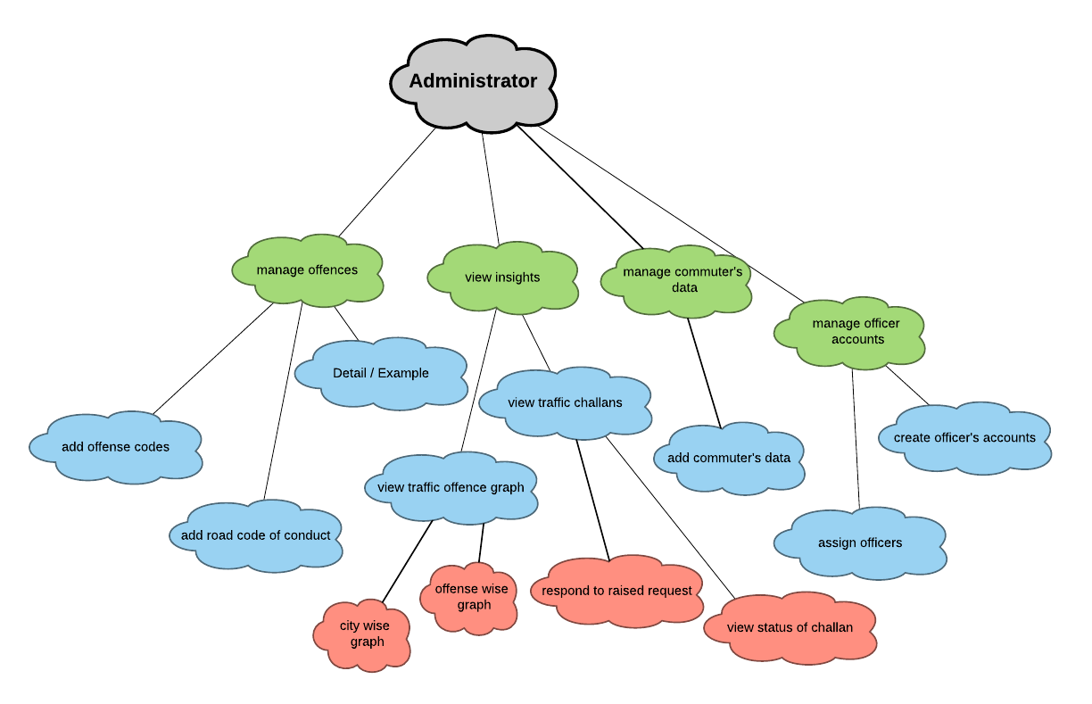**

**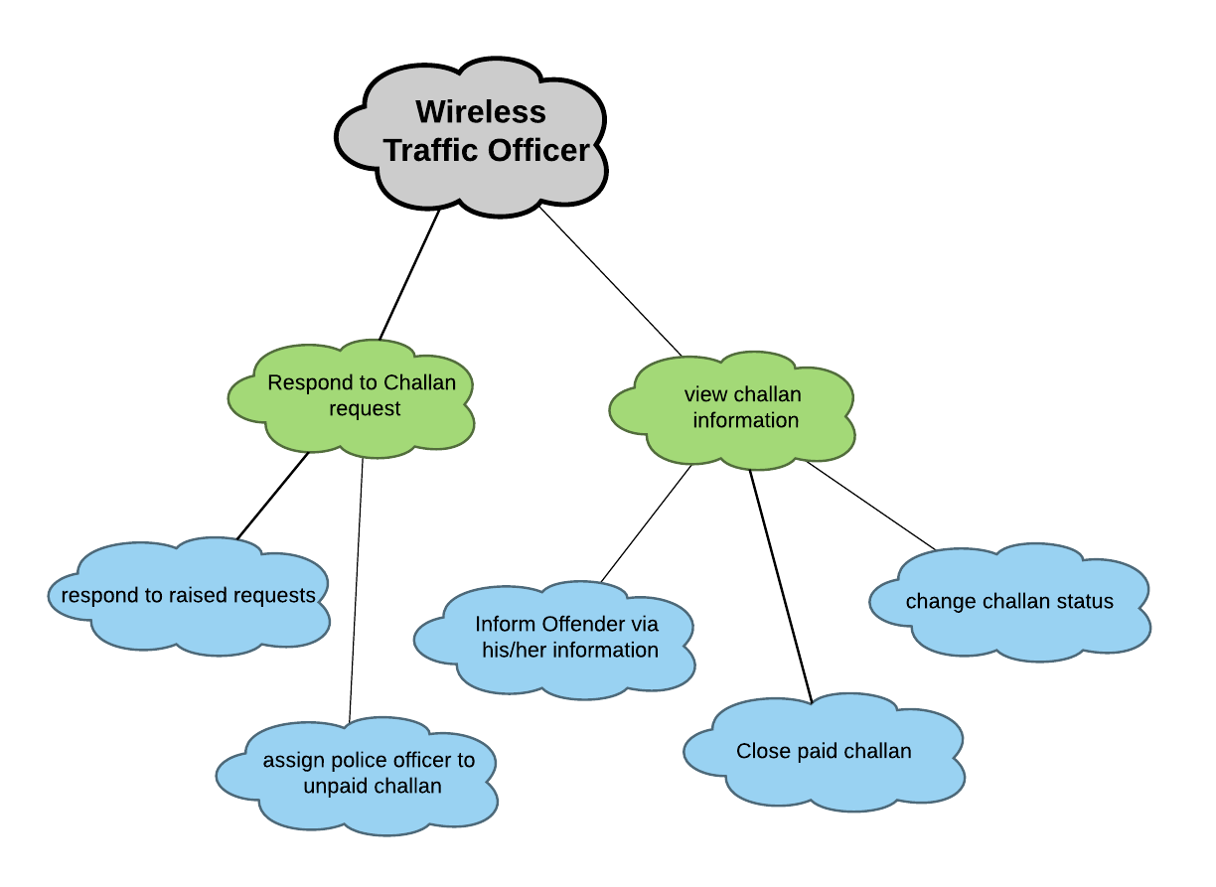**

[**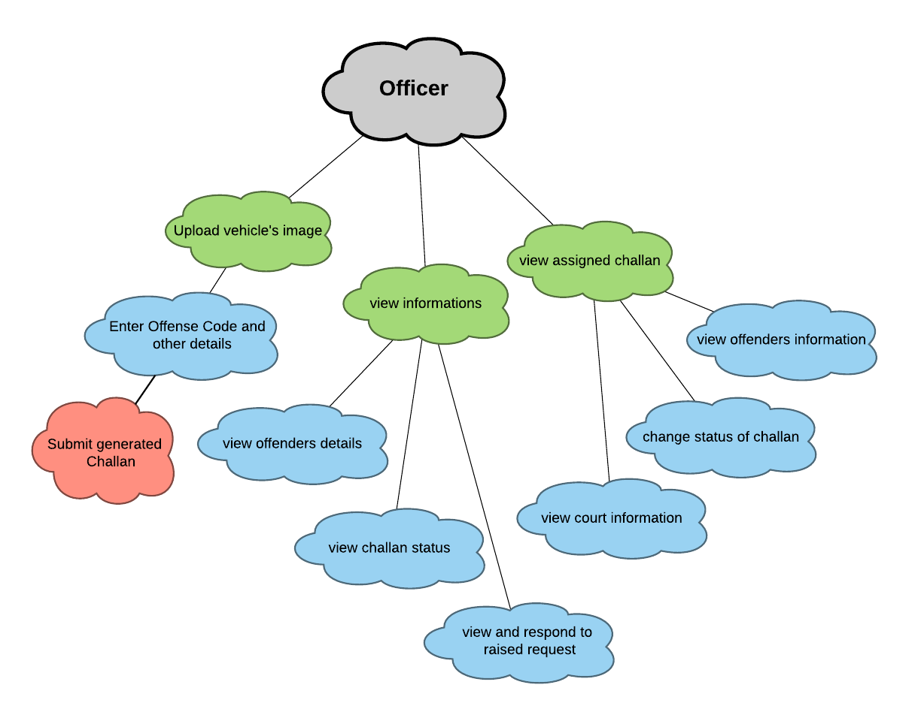**](https://www.lucidchart.com/documents/edit/ce7b4e94-f7a5-4953-b26e-1a3334af5821/0?callback=close&name=docs&callback_type=back&v=1129&s=612)[**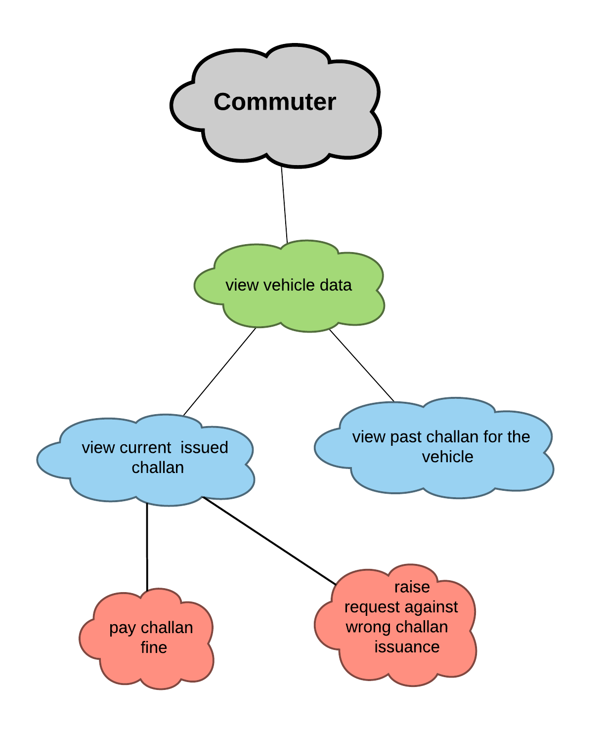**](https://www.lucidchart.com/documents/edit/51aec5b3-a41a-41b3-854e-e1c8e1702908/0?callback=close&name=docs&callback_type=back&v=962&s=612)

## Section 10

**UI/UX Designs (Wireframes) – For the Sprint 3 functionality**

**Home Page**

**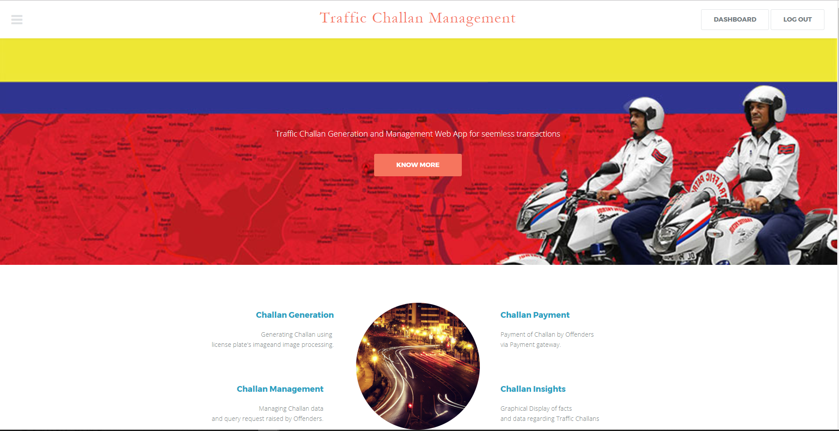**

**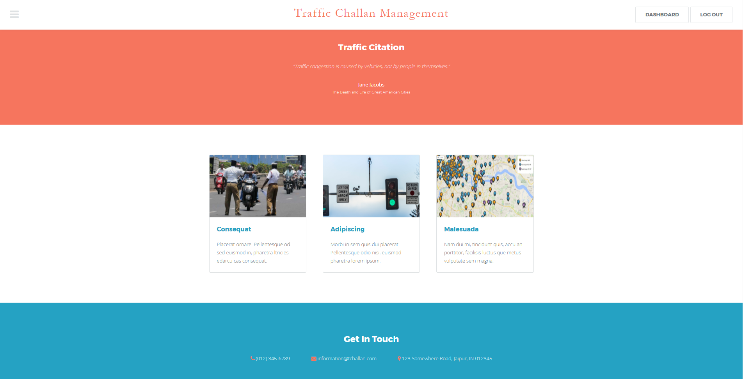**

**Upload Image**

**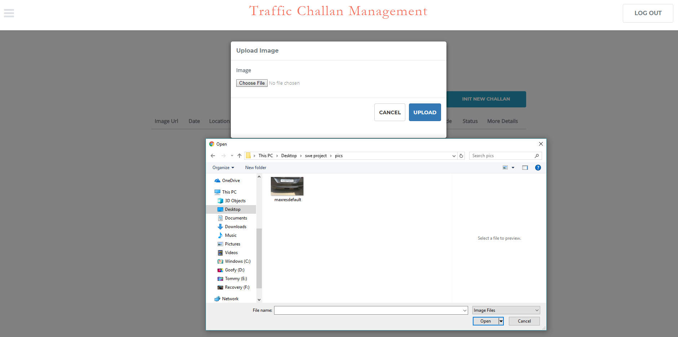**

**Loader**

**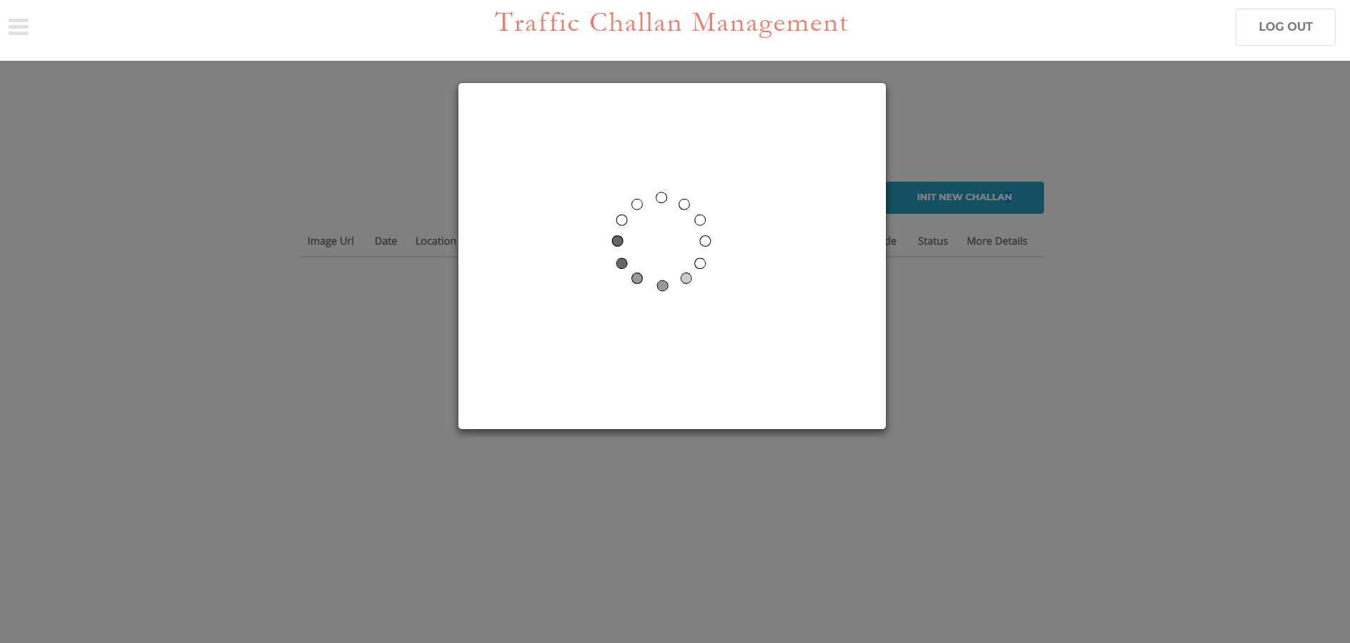**

**Select License**

**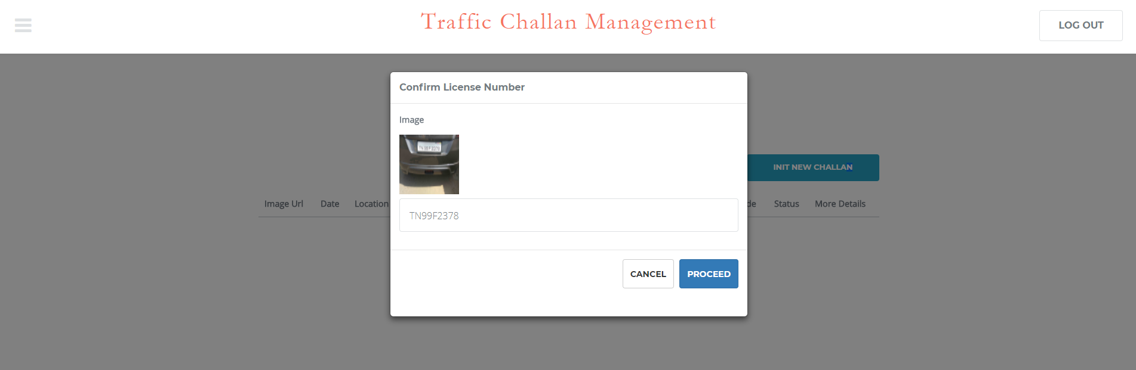**

**Admin Dashboard**

**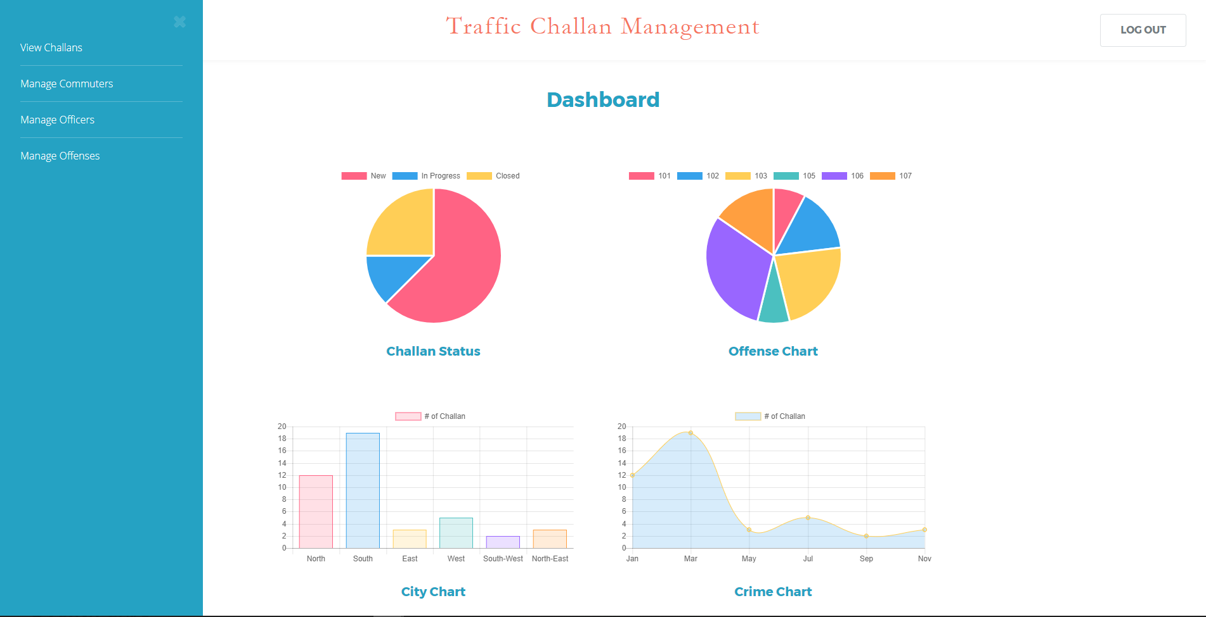**

**Commuter**

**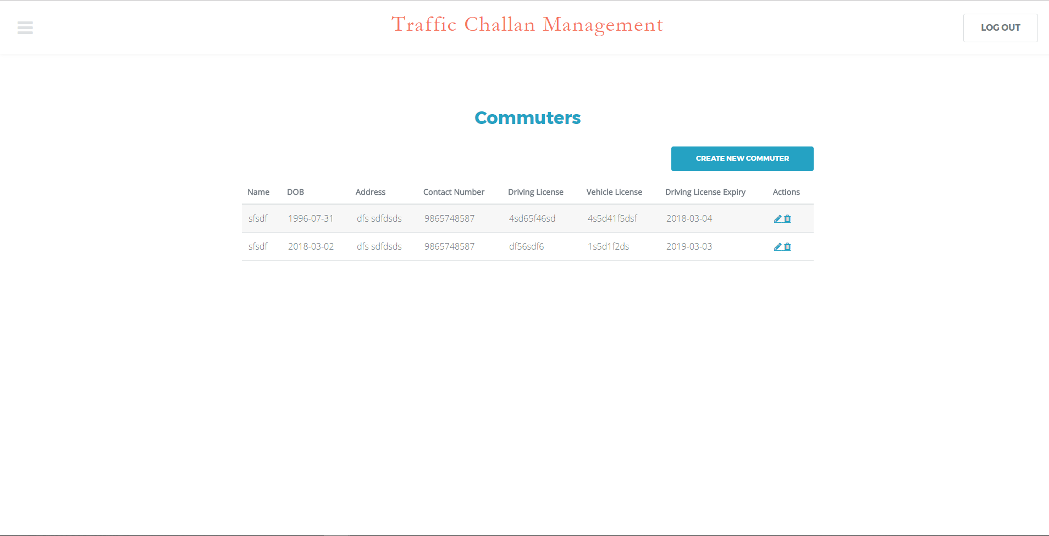**

**Offender Details**

**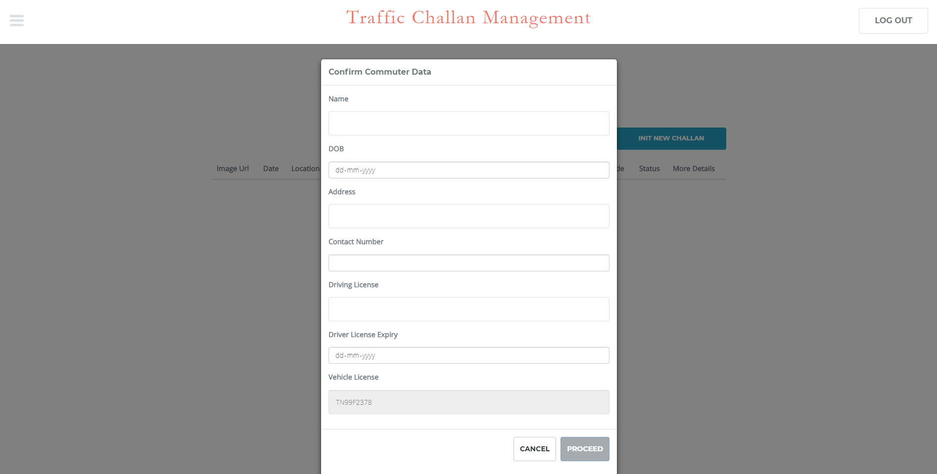**

**Commuter Edit**

**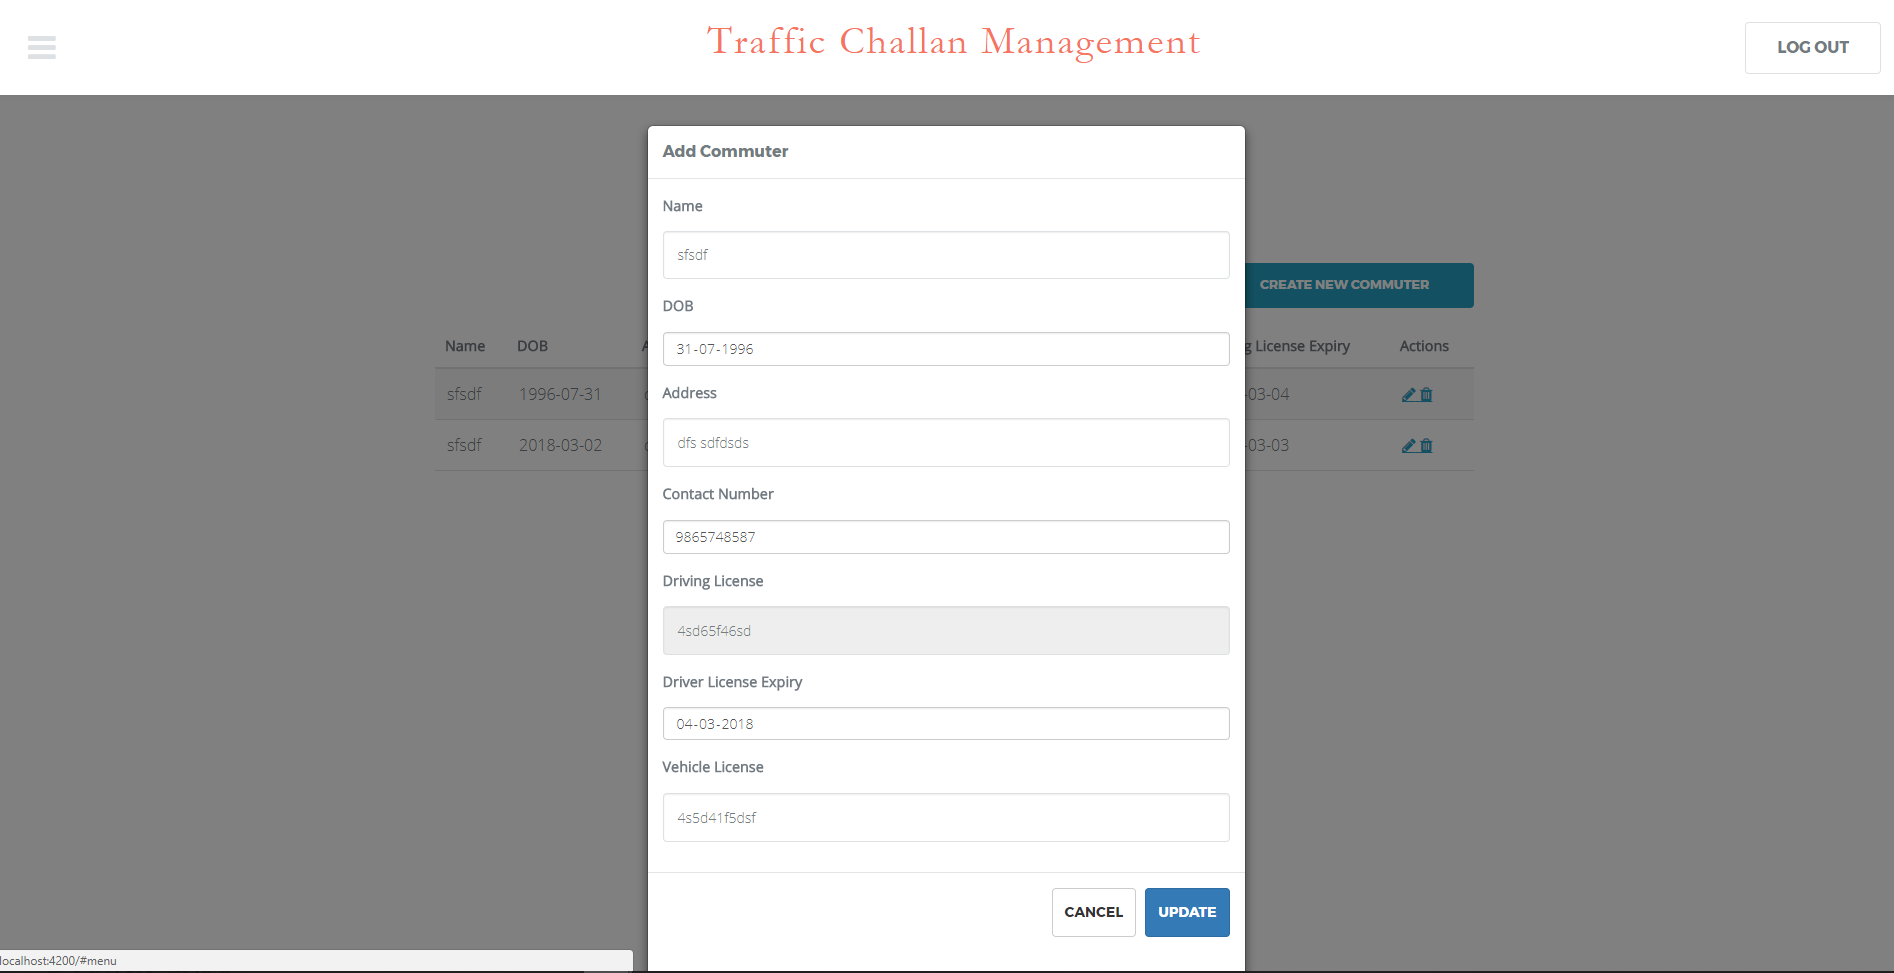**

## Section 11

**Class diagram**

<attributes and operations should be listed on the following pages as a table>

[**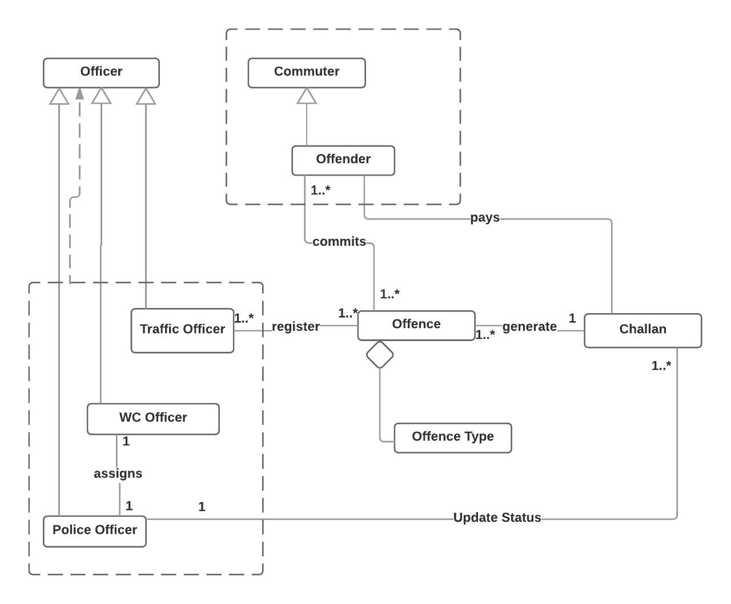**](https://www.lucidchart.com/documents/edit/91d5f803-aef0-4268-8478-fd55957a6d84/0?callback=close&name=docs&callback_type=back&v=3354&s=640)

**Attributes and operations**

(show class attributes and operations with underline)

|  |  |  |
| --- | --- | --- |
| Class name | Attributes | Operations |
| Offence | date  location  offenceType  vehicle\_details | getDetails() |
| Commuter | name  dl\_no  dob  address  contact\_number  dl\_expiry  vehicle\_plate\_number | getCommuter(dl\_no)  getCommuter(vehicle\_plate\_number)  getCommuters()  addCommuter(Commuter)  getAge()  getRemainingDays() |
| Officer | name  precinct  badge\_number  type | getOfficer(badge\_number)  getOfficers()  getOfficers(type)  createOfficer(Officer) |
| Challan | date  location  challan\_number  offence: OFFENCE  offender: OFFENDER  payment\_due\_date  status  officer: OFFICER  court\_date  is\_warrant\_issued  arrest\_status  assignedto | getChallan(challan\_number)  getChallans()  getStatus(challan\_number)  getFine()  getWarrantStatus(challan\_number)  getArrestStatus(challan\_number)  getDueDays() |
| OffenceType | code  description  points  cost | getOffenceCost(code)  getOffences()  createOffence(Offence) |

## Section 12

**System Architecture**

[**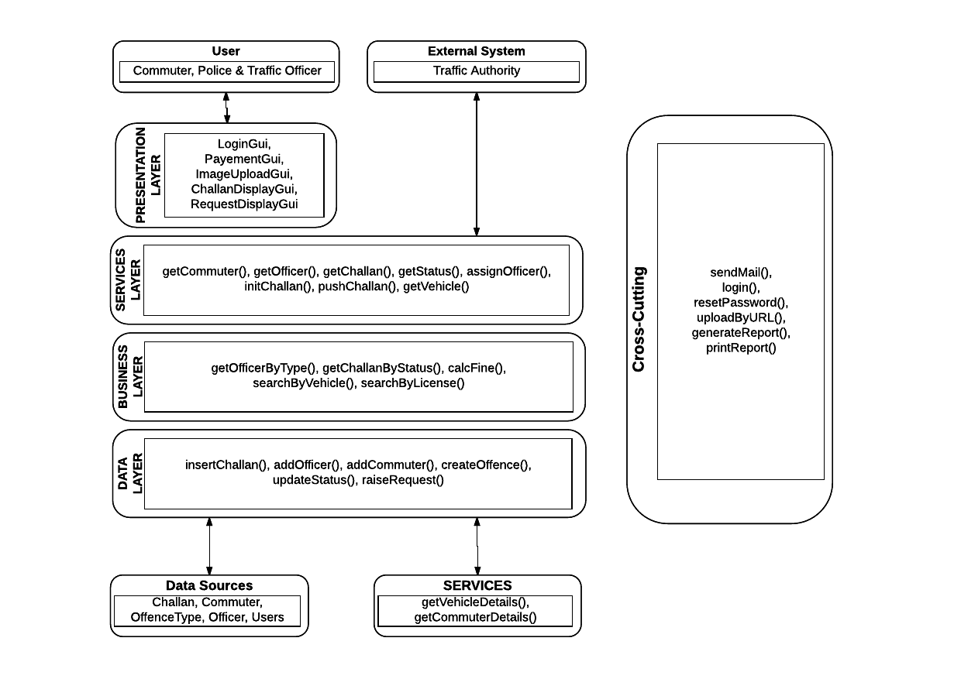**](https://www.lucidchart.com/documents/edit/86f0018b-669b-48d7-9f62-3a98ee2a3dca/0?callback=close&name=docs&callback_type=back&v=2785&s=620)

## Section 13

**User story selected for test case**

|  |  |  |
| --- | --- | --- |
| Story ID | Test ID | Link |
| 1 | B04\_001 | [**TestCase Template**](https://docs.google.com/spreadsheets/d/1XUzCPQ8t4iRSQg33AYg2JlyodljZbwXzFbftXtJaHVE/) |

**Scrum Minutes of the Meeting (Two entries per week for each team member)**

**Sprint 3 – Week 1**

|  |  |  |  |
| --- | --- | --- | --- |
| Team member | Work completed | Work planned | Impediments |
| Rishabh Tiwari | completed | work on payment method | none |
| Satyam Kumar | completed | Add frames to commuters UI | none |
| Satyam Shubham | completed | Add frames to police officer UI | none |
| Shubham Mangal | partially completed | build models and overlay for posting data | none |
| Utsav Singh | partially completed | gather dummy data and license plate pics | none |

**Week 1**

|  |  |  |  |
| --- | --- | --- | --- |
| Team member | Work completed | Work planned | Impediments |
| Rishabh Tiwari | completed | - | none |
| Satyam Kumar | completed | Tested the commuter UI flow | none |
| Satyam Shubham | completed | Tested the police officer UI flow | none |
| Shubham Mangal | completed | build route to change status from court | none |
| Utsav Singh | completed | Add dummy data of commuters | none |

**Week 2**

|  |  |  |  |
| --- | --- | --- | --- |
| Team member | Work completed | Work planned | Impediments |
| Rishabh Tiwari | completed | worked on arrest status flow | none |
| Satyam Kumar | completed | Search for open source payment method | none |
| Satyam Shubham | completed | worked on payment method | no difficulty |
| Shubham Mangal | completed | Added custom payment method | none |
| Utsav Singh | completed | tested the implementation of others | testing and debugging hard |

**Week 2**

|  |  |  |  |
| --- | --- | --- | --- |
| Team member | Work completed | Work planned | Impediments |
| Rishabh Tiwari | completed | worked on miscellaneous UI bugs | none |
| Satyam Kumar | completed | remove the request feature | no difficulty |
| Satyam Shubham | completed | tested overall implementation and removed bugs | no difficulty |
| Shubham Mangal | completed | Tested the dummy payment gateway | no difficulty |
| Utsav Singh | completed | added commuter login | no difficulty |

**Week 3**

|  |  |  |  |
| --- | --- | --- | --- |
| Team member | Work completed | Work planned | Impediments |
| Rishabh Tiwari | completed | test and review | none |
| Satyam Kumar | completed | test and review | no difficulty |
| Satyam Shubham | completed | finally tested and reviewed | no difficulty |
| Shubham Mangal | completed | completed the scrum report and burndown chart | no difficulty |
| Utsav Singh | completed | test and review | no difficulty |

**Sprint 3 Summary**

**Review Summary (about the product)**

|  |  |
| --- | --- |
| 1 | UI/UX are working efficiently,  Commuter as well Officers can login into his/her account,  Database queries are working,  Administrator is able to see all data |
| 2 | Creation of commuter data, offence data is fast,  Officer’s account can be created,  Vehicle’s image can be uploaded,  Challan can be initiated  Data about image is being fetched |
| 3 | website is hosted on firebase |

**Retrospective Summary (about the process)**

|  |  |
| --- | --- |
| 1 | Using NoSql via firestore is proving to be very feasible as database’s schema is changing frequently,  scheming the database is tedious task |
| 2 | Authentication is done via firebase API which is taking care of login and logout of users, |
| 3 | Using Paypal dummy payment gateway for paying challan |